USER'S MANUAL

**Prerequisites:**

1. Plug DC adapter for power supply, you can use 9 volt as well as 12 volt DC adapter. Minimum current requirement is 1 Amps.
2. Camera must be connected via USB port. You can find USB port at the back of the machine.
3. After plugging DC adapter turn on the switch at the back.

**Direction:**

1. When you start the machine, you won’t be able to see anything on LCD screen. It will take 10 to 20 seconds for some message to be appear on LCD screen. If you can’t see anything on LCD screen then refer to ‘Debugging’ section at the bottom of this manual.
2. “ Welcome remove any object..” when this text appears on LCD as shown in fig 1., you can proceed.



fig. 1

1. If appears “failed to fetch crop info” as shown in fig. 2 it states that fetching any update from database was unsuccessful. This can happen if machine is not connected to internet. If you want to get updates then check your internet connection or press ‘B’ to restart the script.

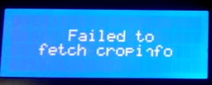

fig. 2

1. “Place your object….” Do as written on screen of weighing machine. Once you put object on the weighing platform, weight of the object will appear in grams at the last line as shown in fig. 3

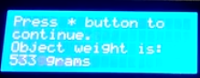

Fig. 3

1. If you wants to tare the weight of the object which is on weighing platform then press ‘D’. Taring of weight can be ONLY done when weight of object is displayed on the screen.
2. After place object on the weighing platform, press ‘*’ to go to the next step. Next step is to enter Crop ID. Enter crop ID and press ‘*’ to confirm the Crop ID as shown in fig. 4

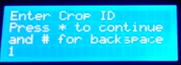

fig. 4

1. Next step is to enter Trough ID. Enter the trough ID and press ‘*’ to confirm the Trough ID as shown in fig. 5

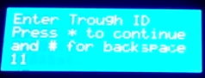

fig. 5

1. After entering Trough ID next step is to enter Location ID. Enter Location ID and press ‘*’ Button to confirm as shown in fig. 6  
    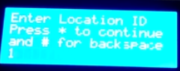

fig. 6

1. For steps 6, 7 and 8:
   1. If mistyped then use “#” button to backspace.
   2. If you enter anything wrong for example if you enter Trough ID wrong the it will show you an error and you won’t be able to proceed further.
2. If it appears “Failed no camera attached” as shown in fig. 7, then check camera connection properly.

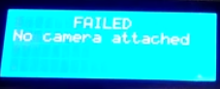

fig. 7

1. “Successful” states that your data have been stored in database as shown in fig. 8.



Fig. 8

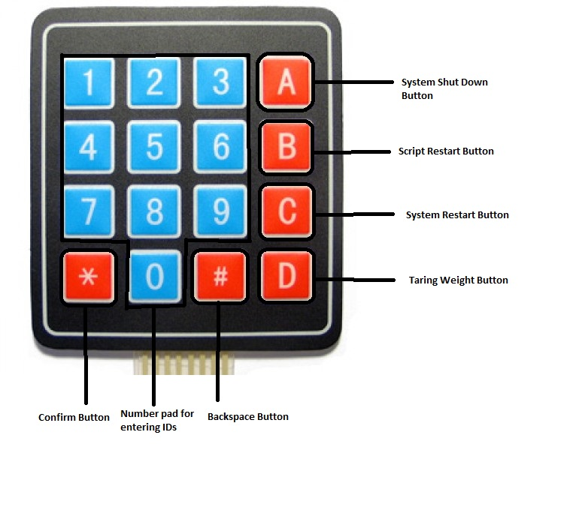

Fig. 9 Keypad Button Mapping

If something went wrong!!

1. Press button “B” to restart script only.
2. Press button ‘C’ to restart the whole system.

After restarting the script or restarting the system if it still not working properly then follow the steps mentioned in ‘Debugging’ Section which you can find at the bottom of the manual.

To Shutdown the system:

Press button ‘A’ to shutdown the system. After shutting down notice the green LED at the left side of machine. DO NOT turn off machine from the plug while this green led is on. When you shutdown the system after pressing ‘A’

**Debugging:**

* When you start the machine and you are not seeing anything on LCD screen after a long period of time. Then make sure that LCD is working properly. Open the front panel by removing two screws on top of front panel and check the connection of LCD. If you want to find that LCD is working or not press ‘A’ button on keypad. It will shutdown the system and green LED at the left side of machine will go off. While shutting down the system if you can’t see anything on LCD screen then replace the LCD screen with new one.
* At start of the system, when system fails to fetch information from server then restart the script. After restarting the script if problem still persist then make sure you are connected to internet and systems’s IP address is configured properly.
* If you see message ‘Camera not attached’ on LCD screen then attach the USB camera in the USB port which you can find at the back of the machine. If camera is attached and it still showing ‘Camera not attached’ then check camera connection or attach new camera.